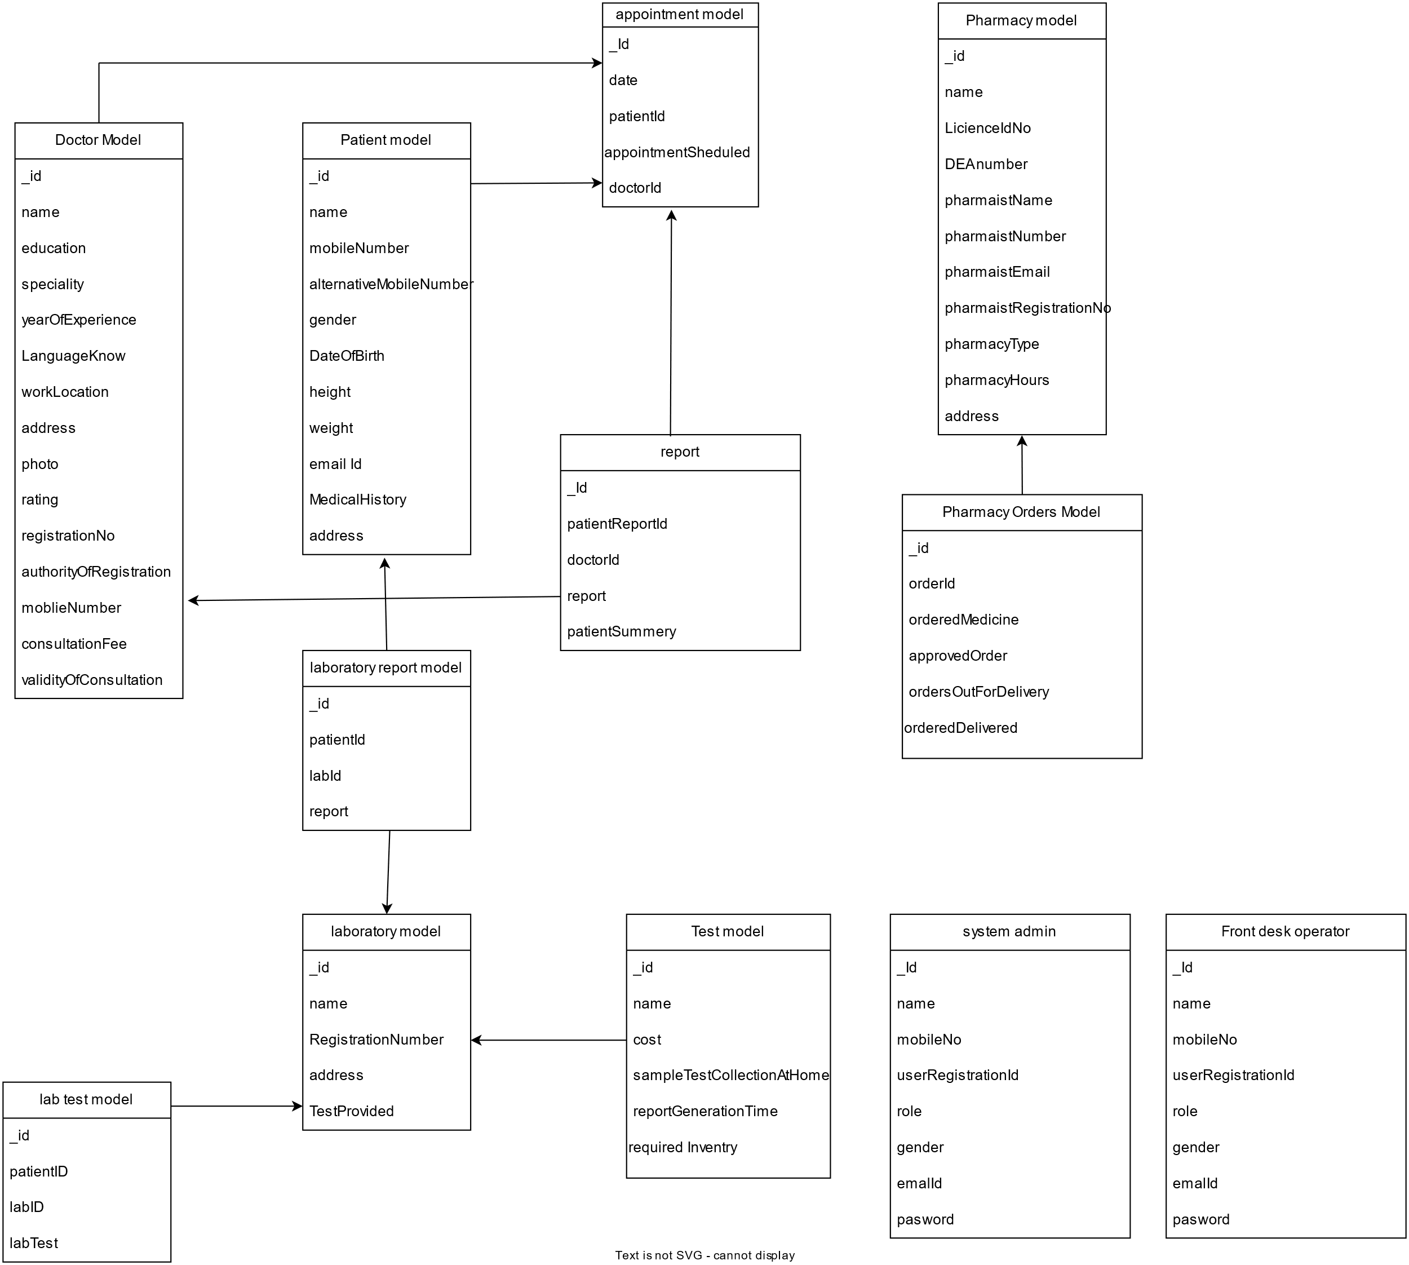

Data base design : [View this diagram online by clicking here](https://tinyurl.com/avanteldbv2)

Flow Diagram : [To view online click here](https://tinyurl.com/avantelflowdiagram)

